1Q) Construct a B+-tree for the following set of key values:
(2, 3, 5, 7, 11, 17, 19, 23, 29, 31)
Assume that the tree is initially empty and values are added in ascending
order.
Construct B+-trees for the cases where the number of pointers that will fit in
one node is five.
Ans) 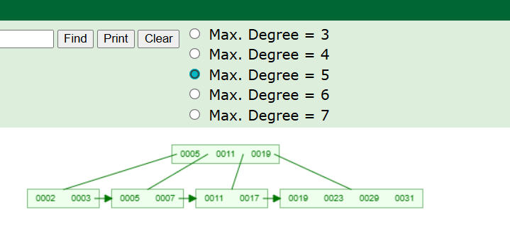
2Q) For each B+-tree of question 1, show the form of the tree after each of the following series of operations: a. Insert 9. b. Insert 10. c. Insert 8. d. Delete 23. e. Delete 19
Ans)
a) 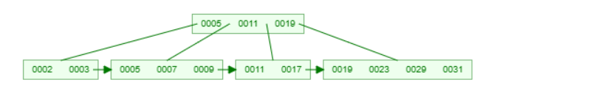
b) 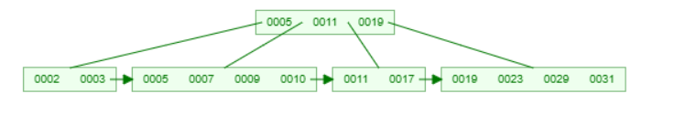
c) 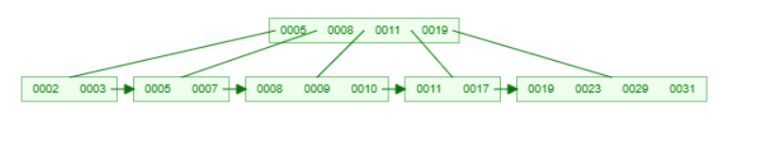
d) 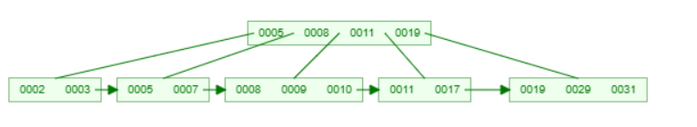
e) 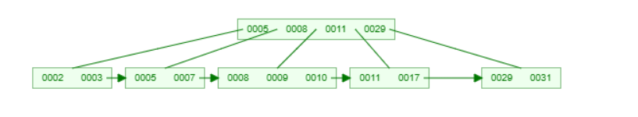
3Q)
Assume that only one tuple fits in a block and memory holds at most three blocks. Show the runs created on each pass of the sort-merge algorithm when applied to sort the following tuples on the first attribute: (kangaroo, 17), (wallaby, 21), (emu, 1) (wombat, 13), (platypus, 3), (lion, 8), (warthog, 4), (zebra, 11), (meerkat, 6), (hyena, 9), (hornbill, 2), (baboon, 12)
Ans)
Pass 0 (initial runs):
- (emu, 1), (kangaroo, 17), (wallaby, 21)
- (lion, 8), (platypus, 3), (wombat, 13)
- (meerkat, 6), (warthog, 4), (zebra, 11)
- (baboon, 12), (hornbill, 2), (hyena, 9)

Pass 1 (after merging pairs):
- (emu, 1), (kangaroo, 17), (lion, 8), (platypus, 3), (wallaby, 21), (wombat, 13)
- (baboon, 12), (hornbill, 2), (hyena, 9), (meerkat, 6), (warthog, 4), (zebra, 11)
Pass 2 (final merge):
- (baboon, 12), (emu, 1), (hornbill, 2), (hyena, 9), (kangaroo, 17), (lion, 8), (meerkat, 6), (platypus, 3), (wallaby, 21), (warthog, 4), (wombat, 13), (zebra, 11)

4Q) Consider the bank database of Figure 15.14, where the primary keys are
underlined, and the following SQL query:
select T.branch name
from branch T, branch S
where T.assets > S.assets and S.branch city = “Brooklynˮ
Write an efficient relational-algebra expression that is equivalent to this query.
Justify your choice
branch(branch name, branch city, assets)
customer (customer name, customer street, customer city)
loan (loan number, branch name, amount)
borrower (customer name, loan number)
account (account number, branch name, balance)
depositor (customer name, account number)
Figure 15.14 Bank database.

